

Programming Fundamentals

Assignment No 9

Student Name :MOMIN HAYAT KHAN

Roll No: S20-0273

Department :BS(Artificial Intelligence)

Batch / Year:SPRING 2020

Lecturer: Mam Misbah

Program No 1:

Write a program that prints the values from an array using pointer variable. The array is given below

int y [ 10 ]= {6,2,3,12};

|  |
| --- |
| #include<iostream>  using namespace std;  int main ()  {  int array[10]={6,2,3,12};  int *ptr;  ptr=array;  for(int i=0; i<4; i++)  {      cout<<*(ptr++)<<endl;  }  } |

Output:

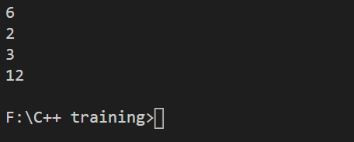

Program No 2:

Print the values and memory address from an array

Write a program that prints the values from an array using pointer variable. The array is given below

int y [ 10 ]= {6,2,3,12};

|  |
| --- |
| #include<iostream>  using namespace std;  int main ()  {  int array[10]={6,2,3,12};  int *ptr;  ptr=array;  for(int i=0; i<10; i++)  {  cout<<"Value : "<<*(ptr++)<<endl;  cout<<"Memory Address : "<<&array[i]<<endl;  }  return 0;  } |

Output:

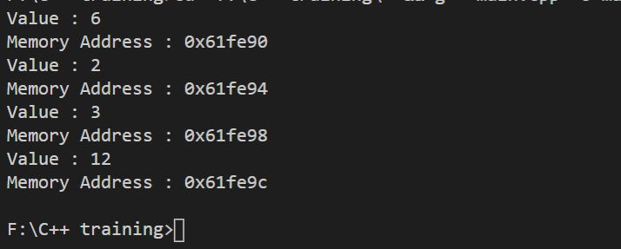

Program No 3:Accessing values by Arithmetic operator.

Write a program that displays the values using pointer variable from an array given below using Arithmetic Increment operator.

int y[5]={22,33,44,55,66};

|  |
| --- |
| #include<iostream>  using namespace std;  int main()  {      int arr[5] = {22,33,44,55,66};      int *ptr;      int j=0;      ptr = arr;      while(j < 5)      {          cout<<*(ptr++)<<endl;          j++;      }  } |

Output:

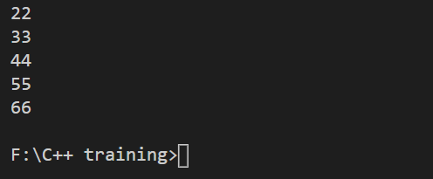

Program No 4:

Write a program that display only 6th element of an array given below using pointers.

int y [10] ={11,22,33, 44,55,66,77,88,99,110}

|  |
| --- |
| #include<iostream>  using namespace std;  int main ()  {  int array[10]={11,22,33,44,55,66,77,88,99,110};  int *ptr;  ptr=&array[5];  cout<<"The 6th Element of array is : "<<*ptr;  return 0;  } |

Output:



Program No 5:

Swap the same values using pointers.

|  |
| --- |
| #include <iostream>  using namespace std;  void swap(int *x, int *y)  {     int temp;     temp = *x;     *x = *y;     *y = temp;  }  int main()  {     int a=50;     int b=100;     cout << "Before Swapping :  a =" << a << ",  b =" << b << "\n";     swap(&a, &b);     cout << "After  Swapping :  a =" << a << ",  b =" << b << "\n";     return 0;  } |

Output:

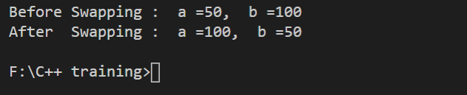

Program No 6:

Write a program that gets the radius from user, pass radius to a function areaperi() and function areaperi() returns ―area‖ and ―perimeter‖ by reference

Using a call by reference intelligently we can make a function return more than one value at a time, which is not possible ordinarily.

|  |
| --- |
| #include<iostream>  using namespace std;  void areaperi(int r, float *peri, float *a)  {  *peri = 2*3.14*r;  *a = 3.14*r*r;  }  int main()  {  int radius;  float area, perimeter;  cout<<"Enter the radius : ";  cin>>radius;  areaperi(radius, &perimeter, &area);  cout<<"Perimeter is : "<<perimeter<<endl;  cout<<"Area is : "<<area<<endl;  return 0;  } |

Output:

